Screenshot 1: Using Chrome for recording
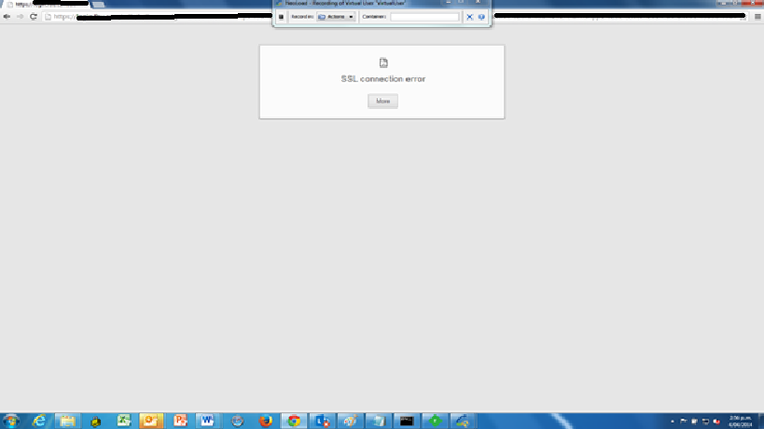

Screenshot 2: Same issue has been noted when tried using IE for recording.

Screenshot 3:
